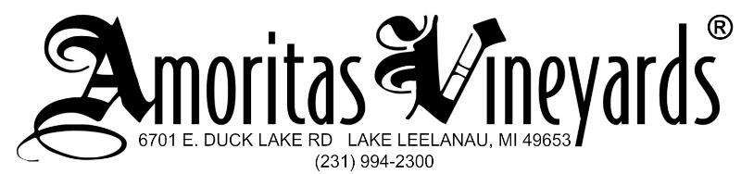

2016 Chardonnay Tech Sheet
$21
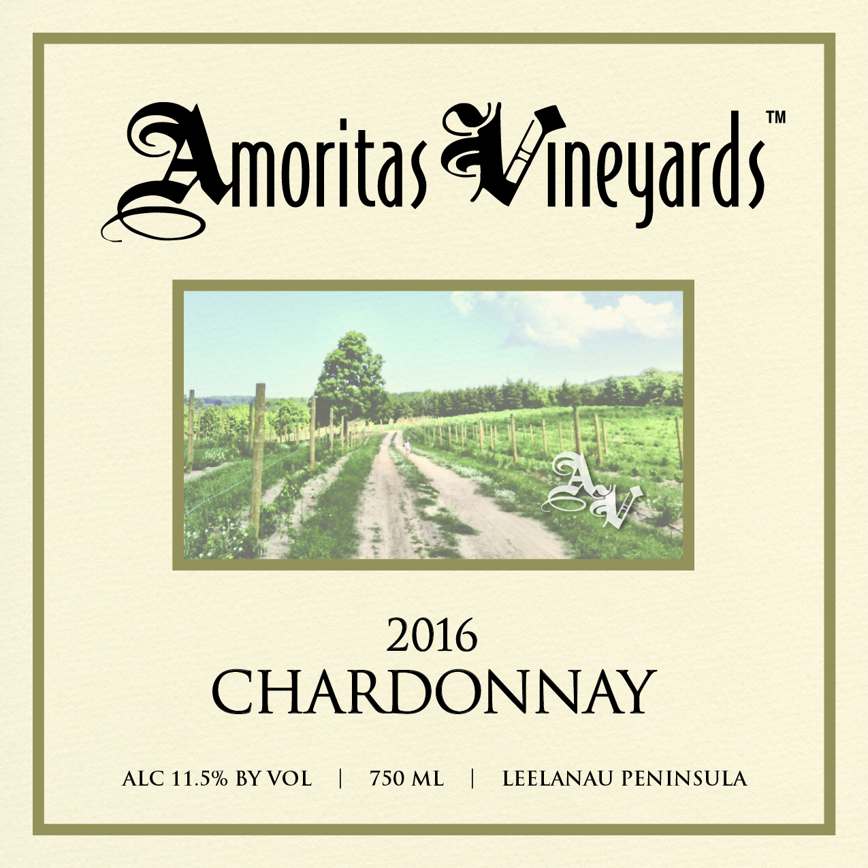
Owners & Growers: Goodell Family (Matt, Emily & Michael)

Winemaker: Charles Schmidt (French Road Cellars Custom Crush)

Vineyard Information:
- 2 acres of Chardonnay in upper Rose Crest Vineyard at Amore Rd farm
- Planted 2013
- Cane Pruned
- Season was long and mild with plentiful rain and a long dry fall.

Harvest Information:9/22/2016 5.45 tons
- Brix 20.8 pH 3.3
- Fruit quality was good, no rot present

Winemaking:
- Stainless Steel Ferment
- Bottled 2/2017
- No Sugar Added, fermented to dryness.

Tasting Notes:
Full of intense flavors. Delicate apple marries with lemon and a long mineral mouthfeel, this is a great wine to play with food pairings.

